How to send money to the CSHS Band Booster program using Zelle!
Zelle is a mobile app that you can send money directly from your banking account to the Band Booster program’s bank account! All you have to do is set it up. It is usually already in your mobile banking application that you have on your mobile device.
Once it is set up, from within your banking application there should be an option to Pay/Transfer. From there you should be able to select Zelle. Once you are in the Zelle app you will want to send money to bandboostercshs@gmail.com (this is a different email account from the one that email correspondence is used, we wanted to keep them separate).
Below are some screen shots of the process!
Once in the Send Money with Zelle section, click the Send button:
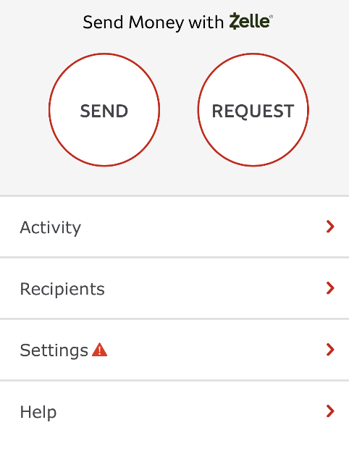
Enter in the email address of the Band Booster Zelle Account: bandboostercshs@gmail.com
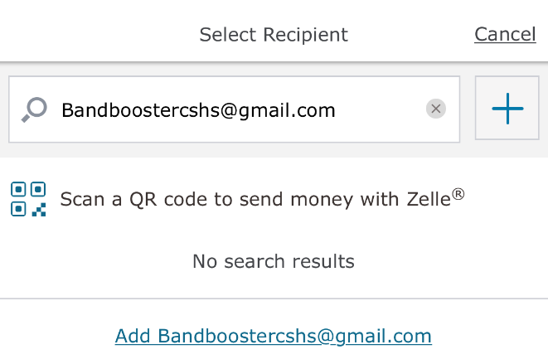

You can add the first name/last name in to create a contact on your app if you wish, then click Continue:
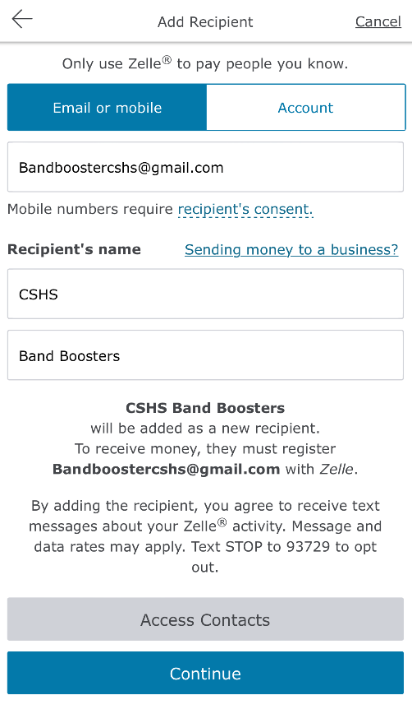
This screen is just making sure the information you added (for your contact for Band Boosters) is correct 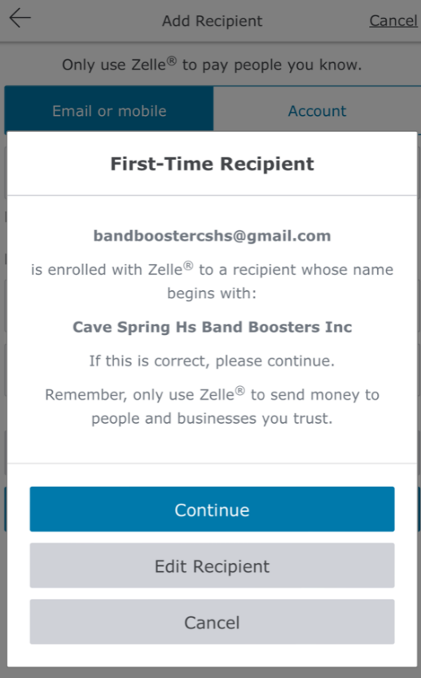

You can then enter in the $ amount you wish to send. Once that is entered, and you click Continue, you should see the screen below to confirm:
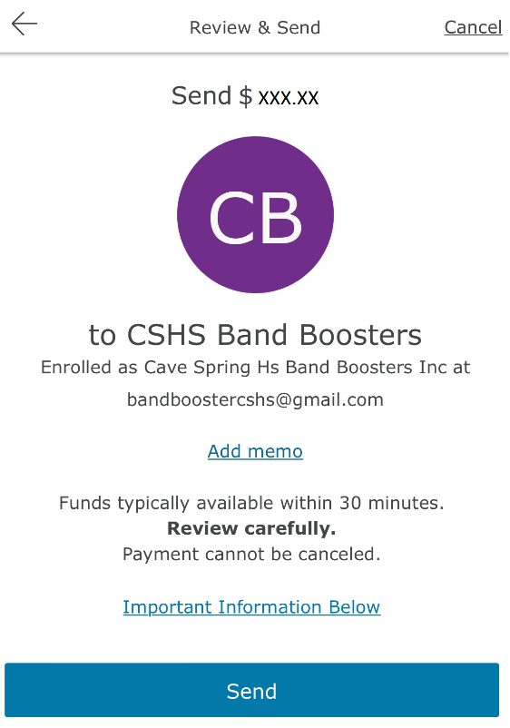
Final Confirmation Screen!
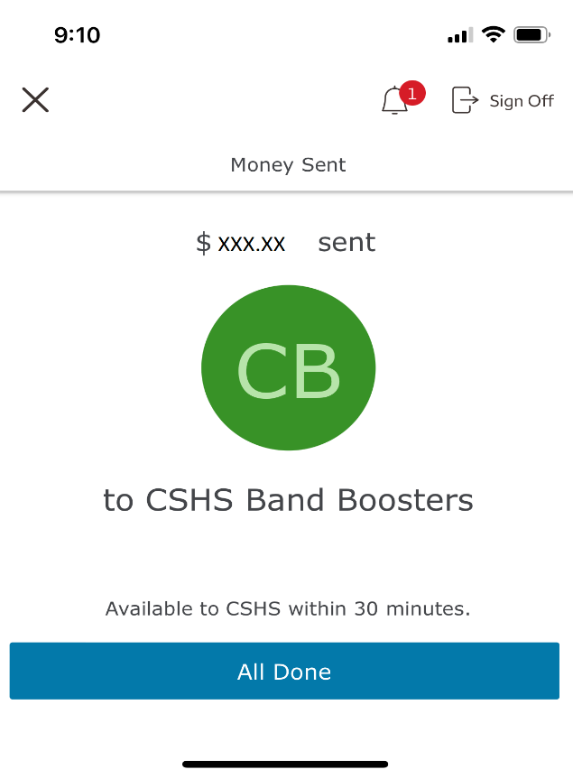
Believe it or not… that’s it! We thank you for your donation!

